HONORS CHEMISTRY • UNIT 7
Gases
Explain gas behavior with moving particles, then predict how pressure, volume, temperature and moles change together.

HOW TO USE THIS PACKET
Write in pencil. For every calculation show the givens with units, the equation, your substitution and the answer with units. Always change temperature to kelvin before you use a gas law. LAB CORNER boxes are things you would see at a lab bench. Extra practice is at the back.

What we will learn
 | Topic
7.1 | Kinetic molecular theory & gas behavior
7.2 | Gas relationships & unit conversions
7.3 | The combined gas law
7.4 | The ideal gas law
7.5 | Gas stoichiometry

By the end of this unit I can…
• Use kinetic molecular theory to explain gas pressure, compressibility and elastic collisions.
• Sketch particle diagrams for a change in temperature, volume or number of particles.
• Decide whether two gas variables have a direct or an inverse relationship and explain why.
• Convert between pressure units (atm, torr, mmHg, kPa, psi) and between °C and kelvin.
• Solve combined gas law problems for any unknown, using kelvin temperatures.
• Use PV = nRT to find pressure, volume, moles, temperature or molar mass.
• Combine the ideal gas law with mole ratios to solve gas stoichiometry problems.

7.1 | Kinetic Molecular Theory & Gas Behavior Moving particles • elastic collisions • pressure • particle diagrams

BIG IDEA
A gas is a huge number of tiny particles flying around in mostly empty space. Everything we measure about a gas (pressure, volume, temperature) comes from how those particles move and hit things.

KINETIC MOLECULAR THEORY (KMT) — THE POSTULATES
1. Gas particles are tiny compared with the empty space between them.
2. Particles move constantly, in random, straight-line paths.
3. Particles do not attract or repel each other.
4. Collisions with each other and with the walls are perfectly elastic: no kinetic energy is lost.
5. The average kinetic energy of the particles is proportional to the Kelvin temperature.

Key vocabulary — write each definition in your own words
Term | Definition (your words) | Example / sketch
Elastic collision | What happens to the total kinetic energy when two particles collide?
Gas pressure | What causes it, and what does it act on?
Kelvin temperature | What is it proportional to? Why must we use it in gas laws?

1. One of the postulates of KMT states that collisions are perfectly elastic. In your own words, describe what this means about the collision.

2. Gases are easily compressible whereas solids and liquids are not. Explain why.

3. How does a gas create pressure on the surroundings?

4. A sample of gas is held in a sealed container, shown below.
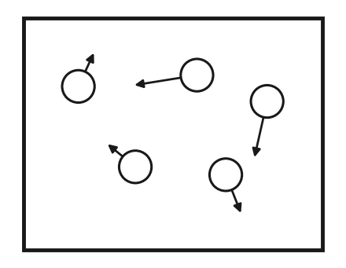 | a. What do the arrows indicate in the diagram?  b. Why are some arrows longer than others?

c. Four boxes are provided below. Each box is a set of conditions changed from the original diagram. In each box, draw how the particles will look (use arrows to show speed).
Same volume  Higher temperature  Same # of particles | Same volume  Same temperature  ½ the # of particles | Decrease volume  Same temperature  Same # of particles | Increase volume  Same temperature  Same # of particles

5. According to KMT, which statement is true for an ideal gas?
A) particles attract strongly B) collisions are perfectly elastic C) particles stop at 25 °C D) particles are touching
7.2 | Gas Relationships & Unit Conversions Pressure • volume • temperature • moles • direct vs inverse • kelvin

BIG IDEA
Four variables describe a gas: pressure (P), volume (V), temperature (T) and moles (n). Change one and the others respond. If two variables go up together the relationship is direct; if one goes up as the other goes down it is inverse.

Direct or inverse?
Variables | What stays the same? | Direct or inverse? | Explain with particles
a. Pressure vs Volume
b. Pressure vs Temperature
c. Temperature vs Volume
d. # Moles vs Pressure

CONVERSION FACTORS
1 atm = 760 torr = 760 mmHg = 101.3 kPa = 14.7 psi K = °C + 273
Set up each conversion as a fraction so the unit you start with cancels. Gas-law temperatures must be in kelvin, never °C.

Perform the conversion (show the fraction setup)
 | Convert | Work and answer (with units)
a. | 35.0 °C to kelvin
b. | 1.25 atm to kPa
c. | 38.0 psi to atm
d. | 745 mmHg to atm
e. | 202.6 kPa to psi
f. | −25 °C to kelvin

LAB CORNER • Sealed syringe

A syringe is sealed with 40 mL of air at 100 kPa. The plunger is pushed in slowly until the scale reads 20 mL. No air escapes and the temperature does not change.
1. (a) Predict the new pressure. (b) Use particles to explain why the pressure changed.
Answer:

1. As the temperature of a gas in a rigid, sealed container increases, the pressure…
A) decreases B) increases C) stays the same D) cannot be predicted
2. 2.00 atm is equal to how many mmHg?
A) 380 B) 760 C) 1520 D) 2000
7.3 | The Combined Gas Law P₁V₁/T₁ = P₂V₂/T₂ • always use kelvin

BIG IDEA
For a fixed amount of gas, PV/T stays constant. So when conditions change from state 1 to state 2: P₁V₁ / T₁ = P₂V₂ / T₂. Boyle’s, Charles’s and Gay-Lussac’s laws are this equation with the variable that does not change crossed out.

STEPS
1. List the givens in a table: P₁, V₁, T₁ and P₂, V₂, T₂ (one is the unknown).
2. Change every temperature to kelvin (°C + 273).
3. Write the equation, solve for the unknown, then substitute with units.
4. Check: does the answer make sense? (Higher T or lower P should make V larger.)

WORKED EXAMPLE
A sealed balloon holds 2.0 L at 1.0 atm and 27 °C. It is carried up a mountain where the pressure is 0.80 atm and the temperature is −3 °C. What is the new volume?

Work it out here:

Solve each problem. Show givens, equation, substitution and answer with units.
 | Combined gas law problems
1. | If I initially have a gas at a pressure of 11 atm, a volume of 23 liters and a temperature of 200 K, and then I raise the pressure to 13 atm and increase the temperature to 300 K, what is the new volume of the gas?
2. | A gas takes up a volume of 18 liters, has a pressure of 2.3 atm and a temperature of 299 K. If I raise the temperature to 355 K and lower the pressure to 1.5 atm, what is the new volume of the gas?
3. | A gas that has a volume of 31 liters, a temperature of 45 °C and an unknown pressure has its volume increased to 36 liters and its temperature decreased to 35 °C. If I measure the pressure after the change to be 2.0 atm, what was the original pressure of the gas?
4. | A gas has a temperature of 13 °C and a volume of 4.1 liters. Calculate the new temperature if the volume of the gas is reduced to 2.5 liters, assuming the pressure stays constant.
5. | If I have 18 liters of gas at a temperature of 67 °C and a pressure of 78.89 atm, what will be the pressure of the gas if I raise the temperature to 94 °C and decrease the volume to 12 liters?

1. A gas at constant temperature is compressed from 4.0 L to 2.0 L. The pressure…
A) is halved B) doubles C) stays the same D) quadruples
2. Which temperature scale must be used in every gas law calculation?
A) °C B) kelvin C) °F D) any, as long as it is consistent
7.4 | The Ideal Gas Law PV = nRT • choose R to match your units • molar mass

BIG IDEA
The combined gas law compares two states of a gas. The ideal gas law describes one state and adds the amount of gas: PV = nRT, where R is a constant. With it you can find any one of P, V, n or T.

Value of R | Use when P is in… | V in… / T in…
0.0821 L·atm / (mol·K) | atm | L / K
62.4 L·mmHg / (mol·K) | mmHg | L / K
8.31 L·kPa / (mol·K) | kPa | L / K

STEPS
1. Convert T to kelvin, V to liters, and P to the unit that matches your R.
2. Solve PV = nRT for the unknown (n = PV/RT, V = nRT/P …).
3. For grams: n = mass ÷ molar mass, so mass = n × M. For molar mass: M = mass ÷ n.
4. Answer with units and the right number of sig figs.

WORKED EXAMPLE
A 5.00 L tank holds nitrogen gas at 2.50 atm and 25 °C. (a) How many moles of N₂ are in the tank? (b) How many grams?

Work it out here:

Solve each problem
 | Ideal gas law problems
1. | A typical human lung has a capacity of 3.90 liters. Assuming the lung has a pressure of 1.00 atm and a temperature of 40.0 °C, calculate the number of moles of gas present in a fully inflated lung.
2. | A sample of nitrogen gas contains 0.921 moles at a pressure of 1.38 atm and a temperature of 316 K. What volume does this gas sample occupy?
3. | A sample of chlorine gas occupies a volume of 35.5 L at a pressure of 790 mmHg and a temperature of 100.0 °C. Calculate the number of grams of chlorine present in that sample.

4. A student obtains an unknown liquid, Substance A, that readily evaporates into a gas. The goal is to find the molar mass of the gas. The diagram shows the setup. (The particles only show that A has turned into a gas; do not count them in any calculation.)
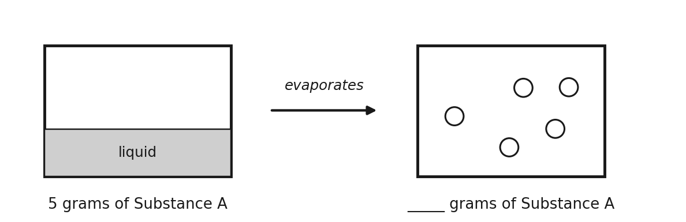
 | Parts a–e
a. | The liquid evaporates into the container. If all of it is now gas, how many grams of gas are present? Write your answer under the box that contains the gas.
b. | What are the units of molar mass?
c. | The container has a volume of 5.00 liters and a temperature of 25.0 °C. The pressure produced by the gas is 1.25 atm. Calculate the number of moles of gas present.
d. | Using the given information and your answer to part c, determine the molar mass of Substance A.
e. | The student repeats the experiment with 10.0 grams of Substance A. Do you expect the calculated molar mass to be higher, lower or the same as in part d? Explain.

1. Which value of R is used when pressure is in atm and volume is in liters?
A) 62.4 B) 0.0821 C) 8.31 D) 22.4
7.5 | Gas Stoichiometry Grams → moles → (mole ratio) → moles → liters

BIG IDEA
Moles are the bridge. The balanced equation gives the mole ratio, and PV = nRT converts moles of gas into a volume (or a volume, pressure and temperature into moles).

ROAD MAP
grams of A → (÷ molar mass) → moles of A → (mole ratio from equation) → moles of B → (V = nRT / P) → liters of B
Going the other way: V, P, T of a gas → n = PV / RT → mole ratio → moles → grams (× molar mass).

WORKED EXAMPLE
Zn + 2HCl → ZnCl₂ + H₂. 3.27 g of zinc reacts completely. What volume of H₂ forms at 1.00 atm and 25 °C?

Work it out here:

1. Gasoline is mostly octane (C₈H₁₈), which burns in oxygen to give carbon dioxide and water.
 | Octane combustion
a. | Write the balanced chemical equation for the combustion of octane.
b. | A gallon of gasoline has a mass of roughly 4000.0 grams. How many liters of CO₂ will be produced at 21.0 °C and 1.00 atm if 1 gallon of gasoline is combusted?
c. | Assuming the same temperature and pressure as part b, how many liters of oxygen gas are consumed?
d. | The enthalpy of combustion (ΔH) of octane is −5,460 kJ/mol rxn. Calculate the energy released in the combustion of 1 gallon of octane.

2. A student performs the experiment below to collect the gas produced by the decomposition of sodium azide.
Reaction: ___ NaN₃(s) → ___ Na(s) + ___ N₂(g)
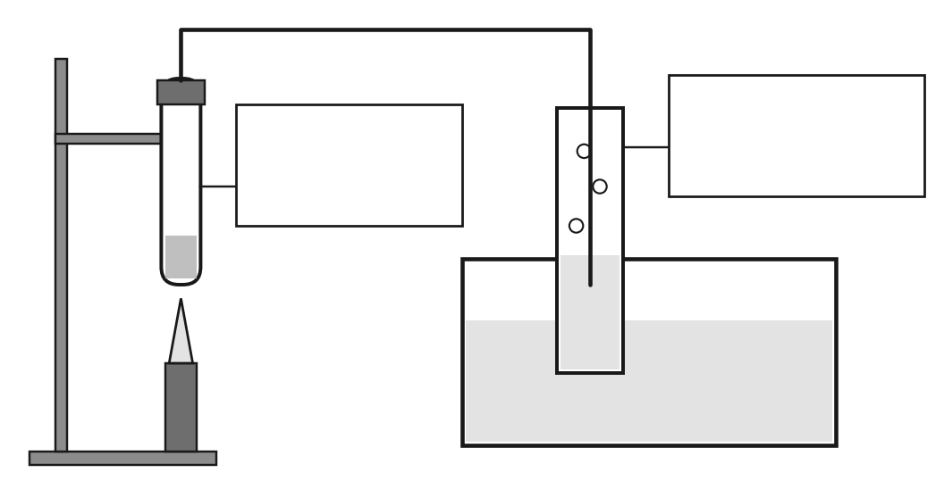
 | Sodium azide
a. | Label on the diagram where the reaction occurs and where the gas is collected (in the boxes).
b. | Sodium azide is a solid at room temperature. Using your knowledge of types of compounds, explain why.
c. | 10.0 g of solid NaN₃ is decomposed and the gas collected. The pressure is 0.98 atm and the temperature is 32.0 °C. Calculate the volume, in mL, of N₂ produced.
d. | An airbag needs about 75.0 L of N₂ at 1.0 atm and 350 K. How many grams of NaN₃ must be decomposed?

1. The mole ratio used in a gas stoichiometry problem comes from…
A) the molar masses B) the coefficients of the balanced equation C) the ideal gas constant D) the subscripts in the formulas

PRACTICE
Extra Practice — Unit 7
Show your work. Kelvin always.

A. Which relationship? (name the law or equation you would use)
 | Situation | Law / equation
a. | A sealed syringe is pushed in; the temperature does not change.
b. | A balloon is placed in a freezer; the pressure stays the same.
c. | A sealed aerosol can is heated.
d. | Gas is pumped into a rigid tank; find the moles added.

B. Calculate
 | Problems
a. | A 6.50 L sample of gas at 1.20 atm and 25 °C is compressed to 2.00 L while heated to 60 °C. What is the new pressure?
b. | How many grams of CO₂ are in a 2.50 L tank at 3.00 atm and 27 °C?
c. | CaCO₃ → CaO + CO₂. What volume of CO₂ forms at 1.00 atm and 25 °C when 5.00 g of CaCO₃ decomposes?

C. Gas data
A student traps air in a syringe at constant temperature and records the pressure as the volume changes. Complete the table, then plot V (y-axis) against P (x-axis).
1. What is the relationship between P and V? | 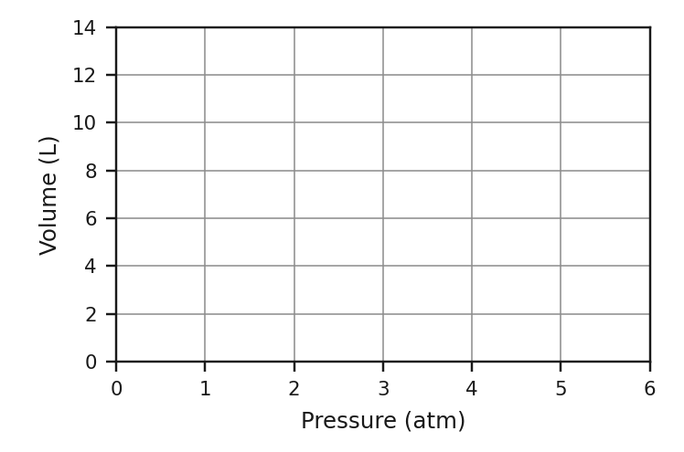
  P (atm) | V (L) | P × V
  1.0 | 12.0
  2.0 | 6.0
  4.0 | 3.0
  5.0 | 2.4

D. Think
1. Explain with particles why a sealed can of spray paint says “do not store near heat.”

2. Which gas sample has more particles: 2.0 L at 1.0 atm and 300 K, or 2.0 L at 1.0 atm and 600 K? Explain.

3. At constant pressure, a gas at 300 K is heated to 600 K. Its volume…
A) doubles B) is halved C) stays the same D) increases by 300 L
4. A gas has a volume of 22.4 L at 1.00 atm and 273 K. How many moles are present (R = 0.0821)?
A) 0.5 mol B) 1.00 mol C) 2.00 mol D) 22.4 mol

